Research of the unrecognised functions of mir-375 in prostate cancer cells

Running TİTLE: Research on the effects of miR-375 in PCa

Merve GOZTEPE^{1*} and Onur EROGLU²
¹Department of Medical Services and Techniques, Vocational School of Health Services, Bilecik Seyh Edebali University, Bilecik, Turkey
²Department of Molecular Biology and Genetics, Faculty of Science, Bilecik Seyh Edebali University, Bilecik, Turkey
*Corresponding author Email: merve.celen@bilecik.edu.tr

Abstract
Many cancers, including Prostate Cancer, have miRNAs with altered expression levels. These miRNAs play a pivotal role in regulating cancer initiation, invasion, and metastasis. miRNAs are an important component in cancer diagnosis and therapy and can play a key role as biomarkers or chemotherapeutic agents. This investigation aimed to show the effects of miR-375 on PCa. In this project, target prediction tools and the KEGG pathway were performed to determine the potential targets of miR-375. Transfection was performed using miR-375 mimic and inhibitor. The actions of miRNAs on cell viability and migration were examined in PCa cells. In addition, qRT-PCR was executed to evaluate changes in gene expression in the PI3K-mTOR pathway. The analyses exposed that the upregulation of miR-375 repressed the viability at 48 h. While stimulation of miR-375 did not repress the migration, suppression of miR-375 reduced the migration at 24 and 48 hours. The predicted target TSC1 gene is not directly targeted by miR-375. Interestingly, in response to PIK3CA increase, mTOR expression was suppressed in all cells except LNCAP cells. In conclusion, miR-375 has anti-proliferative and cell migration inhibitory effects in prostate cancer. However, studies demonstrate that miR-375 may have tumor suppressor and oncogenic effects when considering cell molecular differences.
Keywords: Carcinogenesis, Gene Expression, MicroRNAs, Prostatic Neoplasms, Signal Transduction

- Introduction
Prostate cancer (PCa) has the highest incidence rate among all cancer cases in men in the UK in 2022. Furthermore, prostate cancer has the highest death rate after lung cancer among cancers [1]. Risk-creating factors for prostate cancer include age, genetic mutations, and a family history of cancer [2]. Despite being common cancer, the etiology of prostate cancer is still not fully understood. Several studies have explored the involvement of the androgen receptor (AR) or other key genes in the development and progression of prostate cancer [3, 4]. However, the processes that control the development of prostate cancer remain unclear and require further investigation.
MicroRNAs (miRNAs) are non-coding RNAs that attach to the 3'-UTR of target mRNAs, inducing their degradation or the repression of their translation [5–7]. By binding to the 5'-UTR district of target mRNAs, miRNAs can also increase translation [5]. Each miRNA can regulate multiple molecular processes by targeting hundreds of mRNAs. Therefore, the dysregulation of miRNA expression may affect several mechanisms. Many studies have shown that miRNAs act as tumor suppressors or oncomiRs in various types of cancers, including prostate cancer, and are involved in cancer's developmental stages [8]. MiRNAs are also of great interest as potential biomarkers for cancer detection, progression, and response to treatment [9]. Currently, studies mainly focus on circulating miRNAs found in various body fluids of patients with cancer. The advantages of circulating miRNAs are that they are resistant to degradation by ribonucleases and physiological conditions and can be easily analysed by methods such as PCR [10].
In a study conducted in our laboratory, we observed decreased expression levels of miR-375 in serum samples of PCa patients [11]. After analysing the data, we hypothesised that miR-375 should be the focus of our investigation. Therefore, we aimed to explore their mechanism of action in relation to PCa. Previous studies have shown differences in the levels of miR-375 expression in prostate cancer cells. The expression of miR-375 may vary depending on the presence of AR. It was upregulated in AR-sensitive cells, whereas its expression was downregulated in AR-insensitive cells [12]. Compared to normal cells, it is generally upregulated in cancerous cells [13, 14]. Overexpression of miR-375 has also been affiliated with the metastasis of prostate cancer [15, 16]. miR-375 is crucial for the prognosis of patients with castration-resistant prostate cancer (CRPC) and is a sensitive biomarker [17–19].
As shown in the results, miR-375 are miRNA that may be important for PCa. In this study, genes that could be targets of miR-375 were analysed using miRNA target prediction tools and the effects of genes on the signaling pathway were shown with the KEGG Pathway database. The analyses identified a gene involved in the PI3K/Akt/mTOR signaling pathway, which plays an important role in prostate cancer progression and resistance to treatment [20]. In this study, we intended to elucidate the impact of miR-375 on prostate cancer and its involvement in the PI3K-mTOR signaling pathway. Thus, the mechanisms of miRNA effects on PCa, which are also missing in the literature, will be clarified
- Materials and methods
  - Bioinformatic analyses
The present study utilises several miRNA target prediction tools, including TargetScan, miRDB, miRwalk, and Rna22 to analyse the targets for miR-375.We identified gene lists that are common to four miRNA target prediction tools. To understand the functional properties of potential target genes of miR-375, we conducted Kyoto Encyclopedia of Genes and Genomes (KEGG) pathway (https://www.genome.jp/kegg/pathway.html) analyses. miR-375 target genes confirmed by experimental studies were verified from the miRTARBASE database (https://mirtarbase.cuhk.edu.cn/). Genes that proved to be miR-375 targets were eliminated. in the last step, the predicted target gene was determined according to pathway analyses among other genes in the common gene list.
  - Cell culture
RWPE-1 normal human prostate epithelial cells, AR-sensitive LNCaP prostate cancer cells, AR-insensitive DU-145 and PC-3 prostate cancer cells having different characteristics were recruited for this study. RWPE-1 cells were cultured using 1X K-SFM (1X Keratinocyte-Growth Medium) attached with 50 µg/ml BPE and 5 µg/ml human EGF. LNCaP and DU-145 cells were grown in RPMI-1640 media (Gibco, USA), while PC-3 cells were grown in DMEM - F12 media (Gibco, USA). These media were augmented with 10% (v/v) FBS, Pen/Strep. (10X) solution. All cells were defended at 37°C in a moisturized incubator (INE 500, Memmert, Germany) with 5% CO2.
  - Transfection
In order to understand how miR-375 regulates PCa cells, a series of transfections was performed. To realise transfection, all cells disseminate at a density of 5 × 10⁵ cells/well in 6-well culture plates. Transfection of miRNA mimics, inhibitors and their controls (Ambion, Life Technologies, USA) were done into all cells using ™ 3000 Transfection Reagent by ABP Biosciences (USA) according to the manufacturer's protocol. To determine whether transfection efficiency, KIF11 (Eg5) siRNA (Ambion, Life Technologies, USA) were utilised for the cells. A total of 70 pmol of miRNA mimics, inhibitors, and negative controls along with 7 μl LipoFectMax™ 3000 per well were used. After 48 hours, RNA was extracted.
  - Cell viability assay
DU-145 and PC-3 cells disseminate at a rate of 0,1×10⁴ cells/well in 96-well culture plates. After overnight incubation, cells were dealt with miR-375 mimic, inhibitor, and their controls through 48 h. In the next step, the cells were blotted with crystal violet and incubated with methyl alcohol. To interpret cell viability, measurements were carried out using a MultiScan FC microplate reader (Thermo Scientific, USA) at a wavelength of 570 nm.
  - Wound healing assay
DU-145 cells disseminate at a rate of 0,5×10⁴ cells/well in 6-well culture plates. When cells reached 95% confluence, the cell layer was scratched using a pipette tip. After the wound was created, cells were dealt with miR-375 mimic, inhibitor, and their controls through 48 h and images were taken at 0, 24 and 48 h via an inverted microscope (Nikon, Japan). The regions of migrated cells in the plotted area were mensurated using Image J software (software (Version 1.53; National Institutes of Health), and the migration rate of cells was evaluated.
  - qRT-PCR
This study used qRT-PCR that one of the most well-known tools for assessing mRNA and miRNA expression levels. The present study utilises A.B.T.™ RNA Purification Kit (A.B.T. Laboratory Industry, Turkey) to analyse for total RNA extraction and A.B.T.™ miRNA Purification Kit (A.B.T. Laboratory Industry, Turkey) for miRNA extraction. The A.B.T.™ cDNA Synthesis Kit (A.B.T. Laboratory Industry, Turkey) was used to perform reverse transcription, following the manufacturer's instructions and the temperature protocol: 10 minutes at 25 °C, 2 hours at 37 °C, and termination at 85 °C for 5 minutes. Stem-loop primers (Table 1) were used for miRNAs, while hexamers were used for total RNA during the reverse transcription. PCR was performed using A.B.T.™ 2X qPCR SYBR-Green Master Mix (A.B.T. Laboratory Industry, Turkey) following the manufacturer's protocols. The table displaying the miRNA and mRNA primer sequences used in the PCR step is presented in Table 2. The following thermocycling conditions were employed: 95°C for 300 seconds, followed by 40 cycles of 95°C for 30 seconds and 60°C for 60 seconds. U6 small nuclear RNA and GAPDH were utilised as internal controls. The relative expression levels were analysed using the 2^{−ΔΔCT} calculation method, and this was done from three independent replicates.
Table 1. miRNA-specific stem-loop primers used for cDNA Synthesis.
Primer definition | Base sequence
Mir-375 stem-loop | GTCGTATCCAGTGCAGGGTCCGAGGTATTCGCACTGGATACGACTCACGC
U6 stem-loop | CTCAACTGGTGTCGTGGAGTCGGCAATTCAGTTGAGAACCATAC

Table 2. The primer sequences of gene amplification by qRT-PCR.
Primer Definition | Base Sequence
miR-375 Forward | AGCCGTTTGTTCGTTCGGCT
Universal Reverse | GTGCAGGGTCCGAGGT
U6 Forward | TCGCTTCGGCAGCACATATACT
U6 Reverse | AACGCTTCACGAATTTGCGTGTC
TSC1 Forward | CCATGCTACCAATGATTCCACA
TSC1 Reverse | GAAGTTGCAAGGGTACATTCCA
PIK3CA Forward | AGAAGCTGTGGATCTTAGGGAC
PIK3CA Reverse | ACCCAGATCACCACTATTATTTGC
RHEB Forward | AGTTGATCACAGTAAATGGACAAGA
RHEB Reverse | TGGAGTATGTCTGAGGAAAGATAGA
MTOR Forward | CAGATGCCAATGAGAGGAAAGG
MTOR Reverse | GTACTCAGCGGTAAAAGTGTCC
GAPDH Forward | AGAAGGCTGGGGCTCATTTG
GAPDH Reverse | AGGGGCCATCCACAGTCTTC

  - Statistical analysis
All analyses were actualized using GraphPad Prism Software 9.0 (GraphPad Software, La Jolla, CA, USA). An independent t-test was carried out on each variable to determine whether meaningful and p value <0.05 was considered significant. The data was achieved at least three independent experiments to ensure reliability.

- Results
  - Identification of potential target genes of miR-375
To determine the potential target genes of miR-375, analysis was performed using miRNA target prediction tools were used. Four prediction programs were used: TargetScan, miRDB, miRwalk, and Rna22. From these 4 different programs, common genes were identified using these four programs. A total of 14 genes encoding miR-375 were identified (Figure 1A). Potential target list; SOCS5, PPARGC1B, PDPK1, CNIH4, ELAVL4, TNPO3, UBE3A, BNC2, ISL2, SLC7A11, WWC2, ZBTB20, TCF4 and TSC1.
To design the planned study, KEGG pathway analyses were performed to determine the signaling pathways in which they are involved. KEGG pathway analysis showed that miR-375 predicted target genes were involved in signaling pathways, such as autophagy, the insulin signaling pathway, and insulin resistance (Figure 1B). TSC1, the miR-375 potential target, was influential in the mTOR signaling pathway (Figure 1C). Akt is activated with PI3K (Class 1A) stimulation, the TSC1/TSC2 complex is suppressed, and mTOR is stimulated by increased Rheb expression. Experimental studies will examine whether miR-375 targets TSC1 and its effects on mTOR signaling.
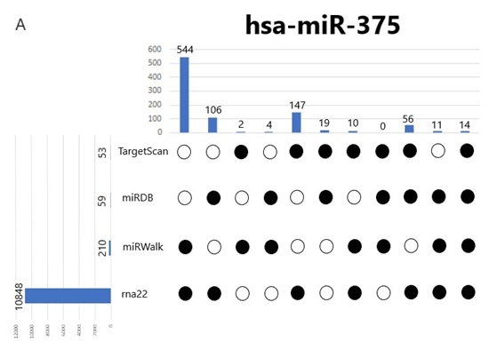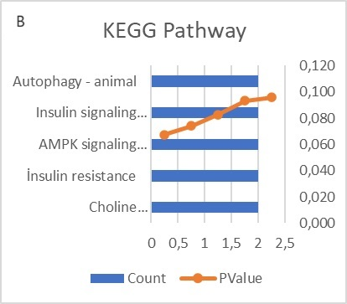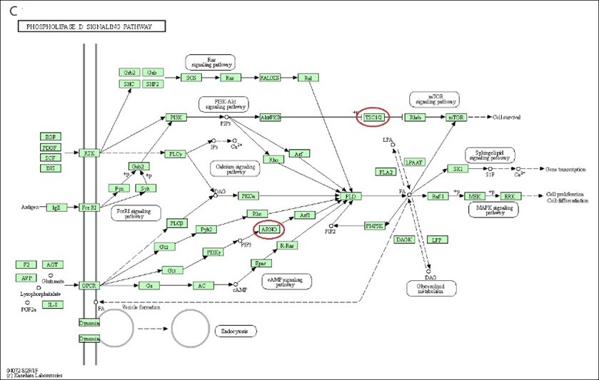

Fig. 1. Bioinfomatic analysis results. A) TargetScan, miRDB, miRwalk, and Rna22 predicted potential targets. Potential target gene numbers of miR-375 are shown. Black dots represent the intersection of the tool’s results. B) KEGG pathway analysis of miR-375 potential target genes. Signalling pathways in which genes are involved. C) An overview of potential target gene (TSC1) involving the mTOR signaling pathway. The red circle represents predicted target genes.
  - Effects of miR-375 on cell viability
This study sought to investigate the effects of miR-375 on cell viability in DU-145 and PC-3 cells. No significant differences were found between inhibitor-treated cells and negative control. On the contrary, in mimic-treated cells, a significant decrease (p<0.05) in cell viability was recorded (Figure 2A and B). Negative controls of the mimic and inhibitor were used as control groups to determine the significance levels.
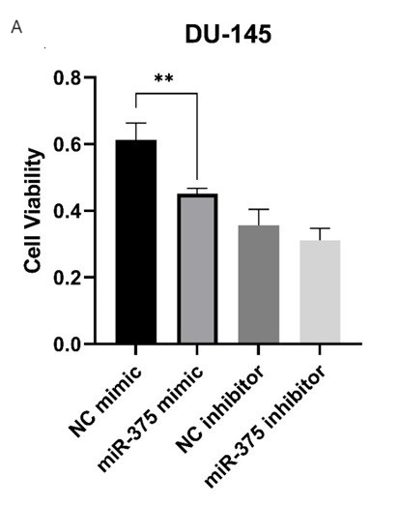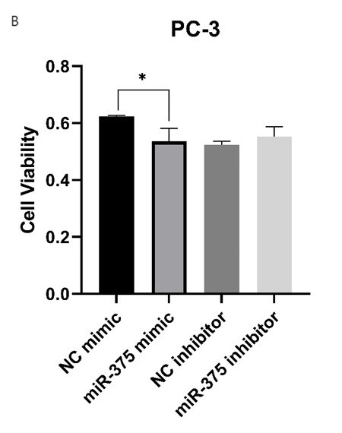
Fig. 2. Graphical representation of cell viability data. A) In mimic- and inhibitor-treated DU-145 cells are presented. B) In mimic- and inhibitor-treated PC-3 cells are presented. Cells treated with negative controls of mimic and inhibitor were used as control. Significance levels were set at the p<0,05 using the student t-test.
  - Effects of miR-375 on cell migration
This study uses a wound-healing assay to investigate the influence of miR-375 in DU-145 cells. The wound width was procured, performing measurements were performed after wound formation at 0, 24, and 48 h (Figure 3A). Overall, miR-375 upregulation did not affect DU-145 cells differently in these measures at 24 h. But the wound width decreased at 48 hours (p<0.05) (Figure 3B). Of interest here is the increase in wound width at both 24 h and 48 h in DU-145 cells treated with miR-375 inhibitor (p<0,05) (Figure 3C).
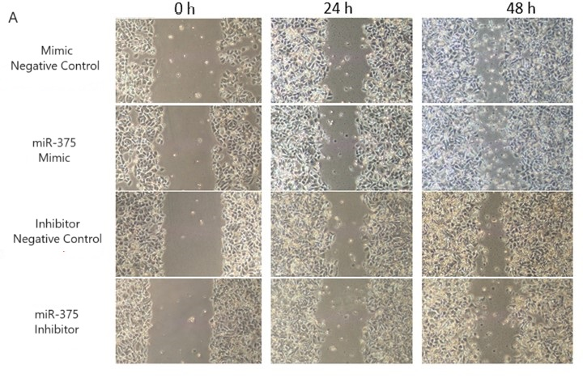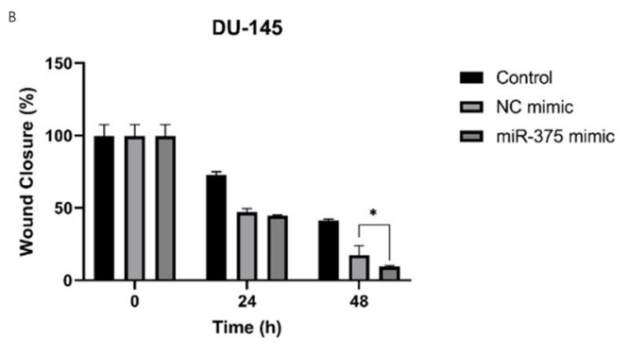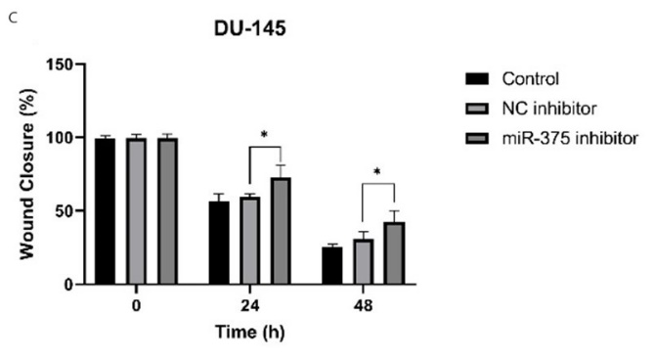
Fig. 3. The wound healing assay results in DU-145 cells are presented. A) Representative images of progression in wound areas plotted on monolayers of DU-145 cells transfected miR-375 mimic and inhibitor. B) It shows a semi-quantitative analysis of wound closure in mimic-treated DU-145 cells. C) It shows a semi-quantitative analysis of wound closure in inhibitor-treated DU-145 cells. The results were evaluated according to changes in wound width compared to mimic and inhibitor negative control. Significance levels were set at the p<0,05 using the student t-test.
  - Effects of miR-375 on the mTOR signaling pathway
This search sought to examine the changes in TSC1 identified as a predicted target by bioinformatic analyses and in PI3K-mTOR signaling by regulation of miR-375 expression. miRNA isolation was performed after transfection, and miR-375 expression levels in cells were analyzed. miR-375 expression levels were increased in mimic-treated cells and suppressed in inhibitor-treated cells (Figure 4A - 4D).
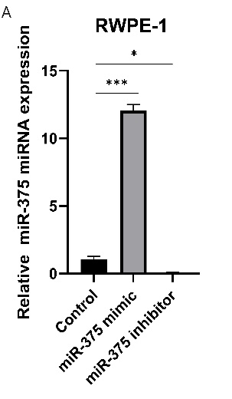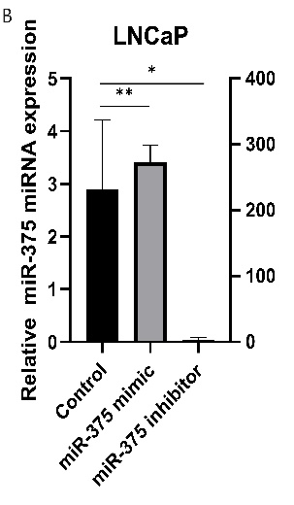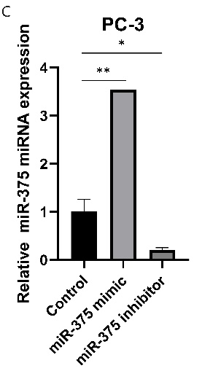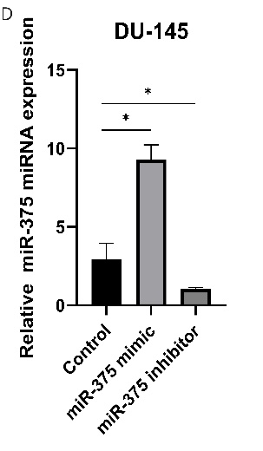
Fig. 4. miRNA expression results of mimic- and inhibitor-treated cells analysed using qRT-PCR. Plotted display of relative expression levels in the A) RWPE-1 cells B) LNCaP cells C) PC-3 cells D) DU-145 cells. The results are shown as the mean ± SE. from three representative independent experiments. *P<0.05, **P<0.01, ***P<0.001, ****P<0,0001 compared with the negative control.
Then, mRNA was isolated from RWPE-1, LNCaP, PC-3, and DU-145 cells, and TSC1, RHEB, MTOR, and PIK3CA expression levels were analyzed. In mimic-treated cells, TSC1 expression level was suppressed in RWPE-1 and PC-3 cells (p<0.05, p<0.01, respectively), while it was increased in LNCaP and DU-145 cells (p<0.01, p<0.01, respectively). In inhibitor-treated cells, TSC1 expression level heightened in RWPE-1 cells (P<0.05) and diminished in PC-3 cells (p<0.01). No significant change occurred in LNCaP and DU-145 cells (Figure 5A).
There was a decrease in RWPE-1 cells (p<0.0001) and an increase in PC-3 cells (p<0.05) when RHEB expression was examined in mimic-treated cells. In the LNCaP and DU-145 cells, there was no significant change. In inhibitor-treated cells, there was a decrease only in LNCaP cells (p<0.05), while no significant expression distinctness was regarded in other cells (Figure 5B).
mTOR expression levels were increased in LNCaP cells (p<0.05) and decreased in RWPE-1, PC-3 and DU-145 cells treated with mimic (p<0.01, p<0.0001, p<0.01, respectively). In inhibitor-treated cells, mTOR expression levels increased in RWPE-1 cells (p<0.0001) and decreased in LNCaP and PC-3 cells (p<0.05). No change was observed in DU-145 cells (Figure 5C).
PIK3CA expression levels were observed to increase in mimic-treated RWPE-1, LNCaP, and DU-145 cells (p<0.05, P<0.05, p<0.01, respectively), except PC-3 cells. While the expression level decreased in RWPE-1 and LNCaP cells treated with inhibitors (p<0.0001, p<0.05, respectively), no change was observed in PC-3 and DU-145 cells (Figure 5D).
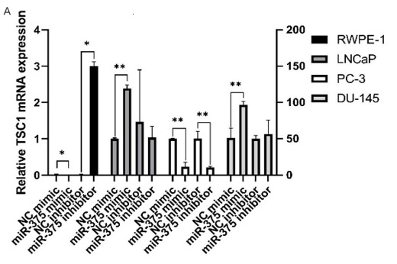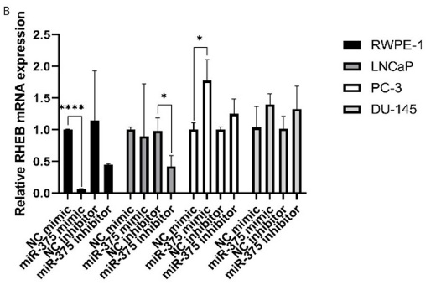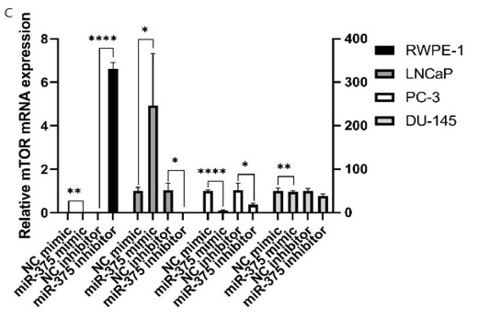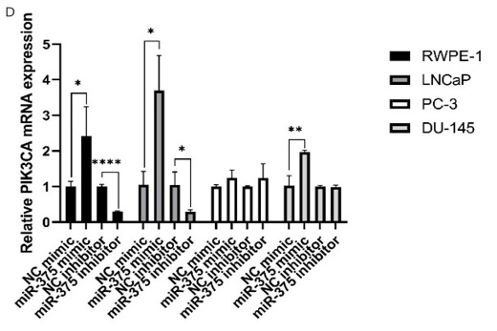
Fig. 5. mRNA expression results of mimic- and inhibitor-treated cells analysed using qRT-PCR. Plotted display of relative A) TSC1, B) RHEB, C) MTOR, and D) PIK3CA expression levels. The results are shown as the mean ± SE. from three representative independent experiments. *P<0.05, **P<0.01, ***P<0.001, ****P<0,0001 compared with the negative control.

- Discussion
Prostate cancer is a highly heterogeneous cancer with a high incidence [21]. Studies on tissue and serum samples from prostate cancer patients showed differences in miRNA expression, including miR-375 [11, 22]. The expression of dysregulated miRNAs may influence various mechanisms that contribute to the development, progression and resistance to therapy of tumor [22]. In this study, we aimed to examine the effects of miR-375, which has been previously shown to have effects on the progression of prostate cancer [23] and the development of resistance to treatment and is important in early diagnosis of the disease.
miR-375 has a dual role and can act as both an oncomiR and a tumor suppressor. Costa-Pinheiro et al. demonstrated that miR-375 expression levels are high in advanced stages of prostate cancer, especially in patients with lymph node metastasis[23]. In addition, in a study, it has been shown that there is an opposite effect between AR absence and DNMT activity, and DNMT regulates miR-375 by changing the methylation levels of the miR-375 promoter [24]. Gan et al. reported that high AR levels of miR-375 may be a new therapeutic target for castration-resistant prostate cancer [25]. AR-sensitive cells such as LNCaP and 22Rv1 have been found to have higher levels of miR-375 expression, while AR-insensitive cells like DU-145 and PC-3 exhibit lower levels [26].
In our study, we desired to investigate the efficacies of miR-375 on cell viability, migration, and PI3K-mTOR signaling pathway in normal prostate cells and androgen receptor-sensitive and insensitive prostate cancer cells. At the same time, TSC1, recognized as the target gene of miR-375 by miRNA target prediction tools, was experimentally validated. Increased miR-375 expression in androgen receptor insensitive DU-145 and PC-3 cells suppressed cell viability. In contrast, in migration experiments applied to DU-145 cells, increased miR-375 levels caused an increase in migration at 48 hours, while decreased miR-375 levels decreased migration at 24 and 48 hours. Increased miR-375 expression decreases cell viability and increases migration, suggesting the dual role of miR-375 in prostate cancer cells. These experiments were applied to AR-insensitive cells, and it is thought that to understand the underlying mechanism, the experiments should be used on AR-sensitive cells, or the effect should be investigated by regulating AR levels.
Bioinformatic analyses revealed that the TSC1 gene is the target of miR-375. At the same time, KEGG analyses revealed that it is effective in PI3K/Akt/mTOR signaling (Fig 2b). In the miRTARBASE database, it was confirmed that ELAVL4 [27], PDPK1 (PDK1) [28], and UBE3A [29]genes, which are among the 14 genes identified as the predicted targets of miR-375 by miRNA target prediction tools, are regulated by miR-375. Our study examined whether miR-375 targets TSC1 in benign prostate cells and prostate cancer cells for the first time by qRT-PCR studies. As a result, the increase/decrease in miR-375 expression levels showed different effects on TSC1 in different cells. This suggests that miR-375 does not directly target TSC1. However, the results should be supported by luciferase reporter assay for clarity.
Wang et al. showed [30] that miR-375 suppresses colorectal cancer growth by targeting the PI3K signalling pathway. However, it discourages cell growth and colony formation and causes cell cycle arrest. In another study, Shi et al. [31] disclosed that miR-375 suppresses tumourigenesis and proliferation in osteosarcoma cells. However, in both studies, miR-375 was shown to bind directly to the 3-UTR region of PIK3CA via luciferase reporter assay. Surprisingly, in our study, miR-375 overexpression led to increased expression of PIK3CA in all prostate cancer cells. It has been shown in previous studies that a single miRNA can both upregulate and downregulate a gene under different conditions [32]. This is exemplified by the fact that miR-344 represses KLF-4 in tumor cells while upregulating it in normal cells [33].
The current investigation found that TSC1 and RHEB expression levels were expressed at different levels in different cells. It is thought that the source of this difference may be the difference in the molecular profile of the cells. LNCaP cells, PTEN, the negative PI3K/Akt stimulation regulator, were mutant. On the other hand, P53 was mutant in PC-3 and DU-145 cells. According to these data, we can infer that miR-375 may act differently. Because distinctions in cells will change the equilibrium.
What is surprising is that it is observed that mTOR is suppressed with miR-375 overexpression in all cells except LNCAP cells, despite the increase in PIK3CA stimulation and to distinction between TSC1 and RHEB expression levels. According to these data, we can infer that miR-375 may act as a tumor suppressor for prostate cancer. However, further studies are required to reveal its effects on the PI3K-mTOR signaling pathway.
These findings suggest that miR-375 has an important role in regulating prostate cancer. Unfortunately, these findings are rather difficult to interpret because miR-375 can behave as a tumor suppressor or oncomiR, belonging to molecular differences in cells or AR sensitivity. The findings reported here shed new light on miR-375 efficiency. However, further research is required to examine the effects of miR-375 for PCa. Thus, the miR-375 effect mechanism can improve, and this information can be used to develop targeted prostate cancer therapy.
- Conclusions
In conclusion, miR-375 has anti-proliferative and cell migration inhibitory effects in prostate cancer. miR-375 expression increase decreases cell viability, while its suppression inhibits migration. It does not target TSC1, which is determined as the predicted target of miR-375 by bioinformatic analyses. However, it also suppresses mTOR signaling, which is important in cancer development.
Abbreviation
AR: Androgen receptor
3’ UTR: 3' untranslated regions
5’ UTR: 5' untranslated regions
BNC2: Basonuclin zinc finger protein 2
CHIN4: Cornichon Family AMPA Receptor Auxiliary Protein 4
CRPC: Castration-resistant prostate cancer
DNMT: DNA methyltransferase 1
ELAVL4: ELAV Like RNA Binding Protein 4
GAPDH: Glyceraldehyde-3-phosphate dehydrogenase
ISL2: ISL LIM homeobox 2
KEGG: Kyoto Encyclopedia of Genes and Genomes
PCa: Prostate cancer
PDPK1: 3-Phosphoinositide Dependent Protein Kinase 1
PIK3CA: Phosphatidylinositol-4,5-Bisphosphate 3-Kinase Catalytic Subunit Alpha
PI3K: Phosphatidylinositol 3-kinase
PPARGC1B: PPARG coactivator 1 beta
PTEN: Phosphatase and tensin homolog
RHEB: Ras homolog enriched in brain
SLC7A11: Solute carrier family 7 member 11
SOCS5: Suppressor of cytokine signaling 5
mTOR: Mammalian target of rapamycin
TCF4: Transcription factor 4
TNPO3: Transportin-3
TSC1: Tuberous sclerosis 1
UBE3A: Ubiquitin-protein ligase E3A
WWC2: WW and C2 domain containing 2
ZBTB20: Zinc finger and BTB domain containing 20
Conflict of interest
The individuals who wrote this piece of writing article disclose no relevant financial or non-financial disagreements of benefit.
Consent for publications
M.G. and O.E. wrote all parts of the manuscript together and read the final version.
Ethical approval
This study did not involve the use of human or animal subjects. Commercial cell lines were used in the study.

Availability of Data and Materials
The data that reinforce the findings of this study are accessible from the corresponding author upon conceivable demand.
Author contributions
MG and OE actively participated in the design of the study. MG was responsible for preparing the material, and collecting and analyzing the data. MG prepared the manuscript for publication, and MG and OE checked the final version. MG and OE confirmed the final manuscript.
Funding
The research was funded by TUBITAK, under Project Number 221Z332.
Acknowledgement
The results shown in this article were part of the PhD dissertation of Merve GOZTEPE. The authors appreciatively render the support provided through TUBITAK (Project No: 221Z332). RWPE-1, LNCaP, PC-3 and DU-145 cells were kindly donated by Professor Hatice Mehtap KUTLU, Associate Professor Bilge DEBELEÇ BÜTÜNER and Assistant Professor Işıl Ezgi ERYILMAZ for our doctorate research project.

References
1. Siegel RL, Miller KD, Fuchs HE, Jemal A (2022) Cancer statistics, 2022. CA Cancer J Clin 72:7–33. https://doi.org/10.3322/CAAC.21708
2. Gann PH (2002) Risk Factors for Prostate Cancer. Rev Urol 4:S3
3. Wang Q, Li W, Zhang Y, Yuan X, Xu K, Yu J, Chen Z, Beroukhim R, Wang H, Lupien M, Wu T, Regan MM, Meyer CA, Carroll JS, Manrai AK, Jänne OA, Balk SP, Mehra R, Han B, Chinnaiyan AM, Rubin MA, True L, Fiorentino M, Fiore C, Loda M, Kantoff PW, Liu XS, Brown M (2009) Androgen Receptor Regulates a Distinct Transcription Program in Androgen-Independent Prostate Cancer. Cell 138:245. https://doi.org/10.1016/J.CELL.2009.04.056
4. Misawa A, Takayama KI, Urano T, Inoue S (2016) Androgen-induced Long Noncoding RNA (lncRNA) SOCS2-AS1 Promotes Cell Growth and Inhibits Apoptosis in Prostate Cancer Cells. J Biol Chem 291:17861. https://doi.org/10.1074/JBC.M116.718536
5. Mirnezami AHF, Pickard K, Zhang L, Primrose JN, Packham G (2009) MicroRNAs: Key players in carcinogenesis and novel therapeutic targets. European Journal of Surgical Oncology (EJSO) 35:339–347. https://doi.org/10.1016/J.EJSO.2008.06.006
6. He L, Hannon GJ (2004) MicroRNAs: small RNAs with a big role in gene regulation. Nature Reviews Genetics 2004 5:7 5:522–531. https://doi.org/10.1038/nrg1379
7. Lujambio A, Lowe SW (2012) The microcosmos of cancer. Nature 2012 482:7385 482:347–355. https://doi.org/10.1038/nature10888
8. Zhang B, Pan X, Cobb GP, Anderson TA (2007) microRNAs as oncogenes and tumor suppressors. Dev Biol 302:1–12. https://doi.org/10.1016/J.YDBIO.2006.08.028
9. Bertoli G, Cava C, Castiglioni I (2015) MicroRNAs: New Biomarkers for Diagnosis, Prognosis, Therapy Prediction and Therapeutic Tools for Breast Cancer. Theranostics 5:1122. https://doi.org/10.7150/THNO.11543
10. Mitchell PS, Parkin RK, Kroh EM, Fritz BR, Wyman SK, Pogosova-Agadjanyan EL, Peterson A, Noteboom J, O’Briant KC, Allen A, Lin DW, Urban N, Drescher CW, Knudsen BS, Stirewalt DL, Gentleman R, Vessella RL, Nelson PS, Martin DB, Tewari M (2008) Circulating microRNAs as stable blood-based markers for cancer detection. Proc Natl Acad Sci U S A 105:10513–10518. https://doi.org/10.1073/PNAS.0804549105/SUPPL_FILE/0804549105SI.PDF
11. Dülgeroğlu Y, Eroğlu O (2019) Diagnostic performance of microRNAs in the circulation in differential diagnosis of BPH, chronic prostatitis and prostate cancer. Turkish Journal of Biochemistry 44:417–425. https://doi.org/10.1515/TJB-2018-0198/DOWNLOADASSET/SUPPL/TJB-2018-0198_SUPPL.DOCX
12. Androgen receptor is negatively correlated with the methylation-mediated transcriptional repression of miR-375 in human prostate cancer cells. https://www.spandidos-publications.com/10.3892/or.2013.2810. Accessed 15 Nov 2023
13. Costa-Pinheiro P, Ramalho-Carvalho J, Vieira FQ, Torres-Ferreira J, Oliveira J, Gonçalves CS, Costa BM, Henrique R, Jerónimo C (2015) MicroRNA-375 plays a dual role in prostate carcinogenesis. Clin Epigenetics 7:1–14. https://doi.org/10.1186/S13148-015-0076-2/FIGURES/10
14. Chu M, Chang Y, Li P, Guo Y, Zhang K, Gao W (2014) Androgen receptor is negatively correlated with the methylation-mediated transcriptional repression of miR-375 in human prostate cancer cells. Oncol Rep 31:34–40. https://doi.org/10.3892/OR.2013.2810/HTML
15. Selth LA, Townley S, Gillis JL, Ochnik AM, Murti K, Macfarlane RJ, Chi KN, Marshall VR, Tilley WD, Butler LM (2012) Discovery of circulating microRNAs associated with human prostate cancer using a mouse model of disease. Int J Cancer 131:652–661. https://doi.org/10.1002/IJC.26405
16. Cheng HH, Mitchell PS, Kroh EM, Dowell AE, Chéry L, Siddiqui J, Nelson PS, Vessella RL, Knudsen BS, Chinnaiyan AM, Pienta KJ, Morrissey C, Tewari M (2013) Circulating microRNA Profiling Identifies a Subset of Metastatic Prostate Cancer Patients with Evidence of Cancer-Associated Hypoxia. PLoS One 8:e69239. https://doi.org/10.1371/JOURNAL.PONE.0069239
17. Bidarra D, Constâncio V, Barros-Silva D, Ramalho-Carvalho J, Moreira-Barbosa C, Antunes L, Maurício J, Oliveira J, Henrique R, Jerónimo C (2019) Circulating MicroRNAs as Biomarkers for Prostate Cancer Detection and Metastasis Development Prediction. Front Oncol 9:441135. https://doi.org/10.3389/FONC.2019.00900/BIBTEX
18. Huang X, Yuan T, Liang M, Du M, Xia S, Dittmar R, Wang D, See W, Costello BA, Quevedo F, Tan W, Nandy D, Bevan GH, Longenbach S, Sun Z, Lu Y, Wang T, Thibodeau SN, Boardman L, Kohli M, Wang L (2015) Exosomal miR-1290 and miR-375 as Prognostic Markers in Castration-resistant Prostate Cancer. Eur Urol 67:33–41. https://doi.org/10.1016/J.EURURO.2014.07.035
19. Zedan AH, Osther PJS, Assenholt J, Madsen JS, Hansen TF (2020) Circulating miR-141 and miR-375 are associated with treatment outcome in metastatic castration resistant prostate cancer. Scientific Reports 2020 10:1 10:1–9. https://doi.org/10.1038/s41598-019-57101-7
20. Shorning BY, Dass MS, Smalley MJ, Pearson HB (2020) The PI3K-AKT-mTOR Pathway and Prostate Cancer: At the Crossroads of AR, MAPK, and WNT Signaling. Int J Mol Sci 21:1–47. https://doi.org/10.3390/IJMS21124507
21. Haffner MC, Zwart W, Roudier MP, True LD, Nelson WG, Epstein JI, De Marzo AM, Nelson PS, Yegnasubramanian S (2021) Genomic and phenotypic heterogeneity in prostate cancer. Nat Rev Urol 18:79. https://doi.org/10.1038/S41585-020-00400-W
22. Schitcu VH, Raduly L, Nutu A, Zanoaga O, Ciocan C, Munteanu VC, Cojocneanu R, Petrut B, Coman I, Braicu C, Berindan-Neagoe I (2022) MicroRNA Dysregulation in Prostate Cancer. Pharmgenomics Pers Med 15:177. https://doi.org/10.2147/PGPM.S348565
23. Costa-Pinheiro P, Ramalho-Carvalho J, Vieira FQ, Torres-Ferreira J, Oliveira J, Gonçalves CS, Costa BM, Henrique R, Jerónimo C (2015) MicroRNA-375 plays a dual role in prostate carcinogenesis. Clin Epigenetics 7:1–14. https://doi.org/10.1186/S13148-015-0076-2/FIGURES/10
24. Chu M, Chang Y, Li P, Guo Y, Zhang K, Gao W (2014) Androgen receptor is negatively correlated with the methylation-mediated transcriptional repression of miR-375 in human prostate cancer cells. Oncol Rep 31:34–40. https://doi.org/10.3892/OR.2013.2810
25. Gan J, Liu S, Zhang Y, He L, Bai L, Liao R, Zhao J, Guo M, Jiang W, Li J, Li Q, Mu G, Wu Y, Wang X, Zhang X, Zhou D, Lv H, Wang Z, Zhang Y, Qian C, Feng MY, Chen H, Meng Q, Huang X (2022) MicroRNA-375 is a therapeutic target for castration-resistant prostate cancer through the PTPN4/STAT3 axis. Exp Mol Med 54:1290. https://doi.org/10.1038/S12276-022-00837-6
26. Chu M, Chang Y, Li P, Guo Y, Zhang K, Gao W (2014) Androgen receptor is negatively correlated with the methylation-mediated transcriptional repression of miR-375 in human prostate cancer cells. Oncol Rep 31:34–40. https://doi.org/10.3892/OR.2013.2810
27. Chen X, Sokirniy I, Wang X, Jiang M, Mseis-Jackson N, Williams C, Mayes K, Jiang N, Puls B, Du Q, Shi Y, Li H (2023) MicroRNA-375 Is Induced during Astrocyte-to-Neuron Reprogramming and Promotes Survival of Reprogrammed Neurons when Overexpressed. Cells 12:. https://doi.org/10.3390/CELLS12172202/S1
28. Ouaamari A El, Baroukh N, Martens GA, Lebrun P, Pipeleers D, Van Obberghen E (2008) MiR-375 targets 3′l-Phosphoinositide-Dependent protein Kinase-1 and regulates Glucose-Induced biological responses in pancreatic β-Cells. Diabetes 57:2708–2717. https://doi.org/10.2337/DB07-1614
29. Gan J, Zhang Y, Liu S, Mu G, Zhao J, Jiang W, Li J, Li Q, Wu Y, Wang X, Che D, Li X, Huang X, Meng Q (2023) MicroRNA-375 restrains the progression of lung squamous cell carcinoma by modulating the ERK pathway via UBE3A-mediated DUSP1 degradation. Cell Death Discov 9:. https://doi.org/10.1038/S41420-023-01499-7
30. Wang Y, Tang Q, Li M, Jiang S, Wang X (2014) MicroRNA-375 inhibits colorectal cancer growth by targeting PIK3CA. Biochem Biophys Res Commun 444:199–204. https://doi.org/10.1016/J.BBRC.2014.01.028
31. Shi Z cai, Chu X rong, Wu Y gang, Wu J hui, Lu C wen, Lü R xiao, Ding M chen, Mao N fang (2015) MicroRNA-375 functions as a tumor suppressor in osteosarcoma by targeting PIK3CA. Tumor Biology 36:8579–8584. https://doi.org/10.1007/S13277-015-3614-9/FIGURES/4
32. Orang AV, Safaralizadeh R, Kazemzadeh-Bavili M (2014) Mechanisms of miRNA-Mediated Gene Regulation from Common Downregulation to mRNA-Specific Upregulation. Int J Genomics 2014:. https://doi.org/10.1155/2014/970607
33. Lin C-C, Liu L-Z, Addison JB, Wonderlin WF, Ivanov A V., Ruppert JM (2011) A KLF4–miRNA-206 Autoregulatory Feedback Loop Can Promote or Inhibit Protein Translation Depending upon Cell Context. Mol Cell Biol 31:2513. https://doi.org/10.1128/MCB.01189-10

