Gallipoli Campaign through the Lens of the Times Newspaper
F. Begum Yildizeli (University of Exeter, Exeter)
Abstract

‘Traveller! Report at Sparta that we are lying in our post’
‘The Message of Gallipoli’, the Times, 28 August 1916
Undoubtedly, the legacy that Gallipoli campaign left to the contracting countries was substantial. Oral defined the campaign as ‘the whole First World War in a cup of tea’ by stating that ‘ships, submarines, mines, planes, war on the soil, balloons—almost everything humankind used in war was used’ during the war in Dardanelles. On this basis, it is vital to examine the roles of the newspapers which kept the connection between the Home and the War Front as well as directing the public opinion. In that respect, the roles of the Times played were vital with regards to British war propaganda as well as informing the public throughout the war. In editorials, published on 29 and 31 July 1914, Wickham Steed, the Times' Chief Editor, argued that the British Empire should enter World War I. Furthermore, the Times occasionally attacked to the government, mainly Lord Kitchener, W. Churchill and Lloyd George, reported the debates in the Houses of Parliament and also included lists of those killed in action or who died of wounds while covering the main events in the battlefield. For instance, on 13 October 1915, the criticism of the Times on Churchill can be considered as a call the British public in a duty, ‘In the Dardanelles affair in particular a megalomaniac politician risked the fate of our Army in France and sacrificed thousands of lives to no purpose.’

Currently, in the 100 anniversary of Gallipoli Campaign, the Times offers the readers the accounts the war day by day. Therefore, this paper will try to examine the representation of the Gallipoli campaign through the lens of the Times archive. The analysis of the process will be generally based on the articles of pivotal events, reports from the war correspondents and the letters to the editors from the public in order to illuminate the necessity of the newspaper. This said, this study will also seek to find possible answers to the questions how the Times covered Gallipoli campaign and to what extend it dominated the British wartime propaganda.

Since its foundation in 1785, the Times is one of the leading national newspapers in Great Britain. From eighteenth century until today, there is little doubt that the Times and related publications have the extensive significance in journalism and press. This said, it can be argued that this estimation is based on its witnesses of wars, revolutions, uprisings and vision of the socio-economic changes of the British governments in domestic politics throughout the eighteenth and nineteenth centuries. Nonetheless, it comes clear that the essentially of the newspaper articles and reports were more conspicuous particularly during the World Wars. In that respect, World War I (WWI) or the Great War can also be defined as the first total war which mobilised the masses without fighting in the troops. Seen in this light, the newspapers were the tools of the society to involve in the war fronts. Undoubtedly, the legacy that Gallipoli campaign left to the contracting countries was substantial. Oral defined the campaign as ‘the whole First World War in a cup of tea’ by stating that ‘ships, submarines, mines, planes, war on the soil, balloons—almost everything humankind used in war was used’ during the war in Dardanelles. In that respect, the roles of the Times played were vital with regards to British war propaganda as well as informing the public throughout the war. Today in 2015, in the 100 anniversary of Gallipoli Campaign, the Times offers the readers the accounts the war day by day. Therefore, this paper will try to examine the representation of the Gallipoli campaign through the lens of the Times newspaper online archive. The analysis of the process will be generally based on the articles of pivotal events of the conflict, reports from the war correspondents and the letters of the readers to the editors from the public in

order to illuminate the necessity of the newspaper. This said, this study will also seek to find possible answers to the questions how the Times covered Gallipoli campaign and to what extend it dominated the British wartime propaganda.
As Buckam in 1930 defines the two angles of influence of the Times on societies both nationally and internationally, ‘For more than a century, the Times is a World Institution of vast power and influence. To Foreign Countries, it has been the voice of Great Britain; to the empire and the dominions of the Mother Country.’ He further suggested that the Times ‘has never lost its character for judicial impartiality’ and ‘at no period has been the mere instrument of Government, party, clique or faction.’ Nevertheless, it should also be noted there were times which the newspaper leaded by the editors’ perceptions and political point of views. When, for example Larkin argued that John Delane who become the editor of the Times in 1841 ‘brought its zenith of influence through his ability to make and maintain social contacts and control editorial policy.’ On this basis, the ‘turbulent’ relationship between the Times and Palmerston ended with the promise of Delane’s support to liberal policies and eventually the Prime Minister converted his ally from the Morning Chronicle to the Times. More to the point, Larkin argued that ‘some 19th-century commentators accused The Times of being swayed by the mood of the public rather than swaying it, and diverging from its editorial policy in order to meet the public’s desire’. Indeed, the Times was obliged to take up a position against the Daily News’ reports of Bulgarian Agitation which substantially awoke the public attention. Prior to beginning of the Great War in 1914, one penny paper journalism was at stake and it was not expected to reduce the price of the Times. Nonetheless, the Times opposed the war-trade for a while, it eventually came out with an announcement on 11 March 1914 that, ‘On and after Monday next, 16 March 1914, the Times newspaper including the Financial section, will be sold at one penny per copy in Great Britain and Ireland, and at Three Pence copy on the Continent.’ This decision, arguably, a revolution within the public opinion and meant that the newspaper reached every region of the British society. Alfred Charles William Harmsworth, 1st Viscount Northcliffe who had the vast influence on public opinion, ‘saw the international crisis, which sent the sale of the times to nearly 300.000, as calling for the exercise of his political powers by helping to organize victory in the war that he had so long believed Germany to be planning.’ In editorials, published on 29 and 31 July 1914, Wickham Steed, the Times' Chief Editor, argued that the British Empire should enter World War I. On 5 August 1914, official British declaration of war published and the day was marked as ‘the momentous in the history of all times.’ Furthermore, the message of the article was explicit and promising with regards to patriotic and religious meanings. As it suggested, ‘We go into it “united, calm, resolute and trusting in God.” That is the mood in which our fathers fought and won. That is the mood, in which we, the true sons will fight today with the humble but firm hope that in a just and righteous cause “the only giver of all victory” will bless our arms.’
Throughout the war, there is little doubt that the Gallipoli Campaign or the war in Dardanelles which took place between 24 April 1915 and 9 January 1916 was one of the touchstones of the Great War. The main aim of the campaign was to seize the control of the straits which were substantially vital for military cooperation for the Entente Powers. The idea was originally promoted by Winston Churchill, First Lord of Admiralty, who aimed to attack ‘the weakest’ enemy and eventually use its strategic position. In a statement to the Dardanelles Commissioners, he pointed out that ‘When at the end of August I formed the opinion that our diplomacy would fail to keep Turkey from joining our enemies; I immediately began to make enquiries from the War Office about the possibility of such an operation… I was perfectly well aware that the right and obvious method of putting a British fleet into the Marmara was an amphibious attack on the Gallipoli Peninsula…’ The British government was so confident of success, and so contemptuous of Turkish fighting abilities, that it did not envisage having to send any troops ashore on the Gallipoli peninsula. More to the point, it can be argued that the Times was also sanguine for the results at the beginning of the campaign. In an article on 1 March 1915, ‘The news from the Dardanelles is extremely favourable and encouraging, though we may reserve jubilation until the difficult operation is complete… We have every reason to hope and believe that the task of forcing the Dardanelles, which the Allied fleets have so admirably begun, will be carried out successfully.’ Another extract from 26 April clearly showed that each attack from Turkish side created immense reactions in the Times. It was stated by a special correspondent that, ‘The days of the Turk in Europe are numbered, and no one will deny that he is dying hard and game. It came as a disagreeable shock to many to read on the morning of 19 March that two British battleships and one French had been sunk into the Dardanelles whilst several others had been hit and damaged.’
Throughout the Gallipoli campaign, the Times systematically informed the public with the maps from the war fronts, included details of the German and Turkish military forces, announced the British and comonwealth deaths, published the letters from the front and gave the full accounts of the Houses of Commons debates. Furthermore, the messages for the Times Fund for Sick and Wounded called the British public in a duty to support the war from the home front in the columns each day. At the beginning of the campaign, it was a special committee with the British Red Cross Society and the order of St. John in the Near East-the Dardanelles, Egypt and Malta. The Fund increased £3952 on 26 April and £1.201.349 in total. This said, following the end of the campaign, it was a call and desire for £5 million until 31 December 1916. In that respect, it is fair to state that the weight of the reports of the Times was clearly received and transformed into a massive assistance to the British army. Beyond the economic aspects of the campaign, the articles as to the unity of the British Empire were also high and crucial for the British policymakers. For this purpose, the Times occasionally published an Empire Day Edition. For instance on 22 May 1915, it was reported that ‘The Empire Day edition comes at an opportune moment this year. Empire Day should utterly remove any tendency towards any pessimism or weariness that may be abroad among the people of Great Britain…It is in this spirit that our Correspondents in various parts of the Empire write. They describe the efforts that the Dominion peoples have made to fit

themselves to take part in that great emergency.’ Seen in this light, following the sending the New Zealanders and Australians to the Dardanelles front, many articles highlighted ‘one people and one flag’ within the British Empire. More to the point, as was stated in article titled ‘a call to the empire’ on 29 June 1915, ‘There is much in the letter from our Australian correspondent which we publish today that is an opportune as it is interesting. The people of Australia, he tells us, have received with a natural pride messages from the King and from the Imperial government praising the gallantry of their troops in the Dardanelles. “Men who never displayed public emotion “before are proud, and say so, to be Australians this day.” With his pride has come an added consciousness of responsibility.’ From this perspective, keeping the public hope and trust to the British army as well as the government high was essential by the newspapers. In that respect, most of the London Press agreed with the author of the history of the Times, which ‘their task was to sustain the morale of the nation in mortal combat’, distinguishing this from ‘fair criticism of the government of the day.’
This said, the question naturally arises, therefore, as to the reflection of the Times on the government and policymakers of the Dardanelles campaign. There is little doubt that the expectation as to a short victory was substantially high. Notwithstanding, there were also calming and protective articles for the ministry published as was on 5 March 1915, ‘The attack on the Dardanelles is making such satisfactory progress that many heads have been perhaps a little turned by the Admiralty announcements. It was not the fault of the Admiralty, whose statements are strictly uncoloured and confined to a guarded of facts. We think the operation has possibly heated the imagination of the public, and stimulated ever-present tendency to see in every fresh success an easy road to the victory.’ On the other hand, the circumstances began to change against the H. Asquith’s ministry. Beyond the failures in British military at the front, the uncertainty as to the censorship of the newspapers was a question. In a House of Commons meeting on 22 April 1915, he further stated that, ‘I can assure my hon. Friend that is the policy of both Admiralty and War Office to publish fully all news, whether favourable or adverse, except in the case of overriding military considerations. Subject only to that condition, I think that there should be the fullest disclosure of all that is

being done by both Navy and Army.’ By the same token, Churchill legitimized his duty in a speech at Dundee on 5 June 1915. The Times defined the speech as ‘largely a call for optimism and action’ and Churchill himself as ‘the jolly good fellow.’ As the war progressed, the Times occasionally began to attack the government, mainly Lord Kitchener, W. Churchill and H. Asquith as the Prime Minister, reported the debates in the Houses of Parliament and also included lists of those killed in action or who died of wounds while covering the main events in the battlefield. For instance, on 13 October 1915, the criticism of the Times on Churchill can be considered as a call the British public in a duty against one politicians’ desire, ‘In the Dardanelles affair in particular a megalomaniac politician risked the fate of our Army in France and sacrificed thousands of lives to no purpose.’ It should also be noted the scholarship on Churchill and his strategy on Gallipoli campaign largely convinced that Churchill was in a hurry to have the victory in a short time. Following the reactions, W. Churchill resigned on 11 November 1915 and the Times announced that ‘Mr. Churchill had resigned his office of Chancellor of the Duchy of the Lancaster and has placed himself at the disposal of the military authorities and his regiment being now in France.’ Moreover, the Times assessed that ‘Mr. Churchill said all he could, and said it very fairly: but at some future time there will be others to be heard before the picture is complete.' following his speech on 15 November.
The war in Dardanelles in the eyes of the British Home Front proceeded with the newspaper articles with regards to heroisms of the Allied powers, particularly Australian, New Zealander and British soldiers. While a fifteen minutes fight portrayed on the advance of the genius strategies of the Australian soldiers, in an extract from 4 September again stated that ‘We speak of them all- Australians, New Zealanders, and Indians-as our man. These are ours as much as those who have gone out from among us-as consciousness of the race, as proud of our traditions, as resolute to maintain our country. When we all think how we have raised to the height so arduous an enterprise we find no words that can express our pride with them.

Ferct erd astra virtus.’ More to the point, in an article from 21 November compared the Trafalgar War in 1805 and the Gallipoli campaign and urged that the British public should stand firm against the naval ‘fiasco’ in Dardanelles.
It is also necessary to consider for this paper how the Turkish and German side were represented for the information of the British society. For instance, the Times correspondent in the Balkan Peninsula reported that ‘the Turks calling up every available man’ and ‘the bravery and enthusiasm of the Turkish officers and soldiers is every day more apparent.’ ‘Through German Eyes’ articles were also systematically informed the public opinion and gave details of the plans of Central Powers. According to the Times correspondent on 11 December, ‘The whole result of the Dardanelles war thus far was that Germany accomplished great things but this “was not victory.”’
To sum up, there is little doubt that outcome of the Gallipoli campaign was beyond the considerations for the nations of British Empire and the policymakers. Needless to say, the Times was one of most prominent brigades between the British Home Front and the war troops with Daily Mail. Along with the patriotic discourses of the editors, the readers called in a duty to assist the British army and navy with the Times Fund and act as a one nation with the other people of the British Empire. In other words, the main goal was also the unity between all parts of the society regardless of their political boundaries against the enemies. Above all, there is a clear sense that the Times succeeded in completing his task on swaying the British public opinion. Finally, it would be fair to state an extract to the editor of the Times at the end of the war on 29 December 1915 which can be considered as an thankfulness of the Times reader, ‘As time goes on, and the eyes of our people are being slowly but surely opened to the intense seriousness of this life and death struggle in which we are locked with Germany, this war to the knife, in which one or other must bite the dust, the nation is beginning to feel the boundless debt of gratitude of which it owes to the Times for its persistent courage in stating the unvarnished truth with regard to the progress of the war and our past deplorable shortcomings, which have been so clearly and so bravely expressed… macto esto virtute (a blessing power)’

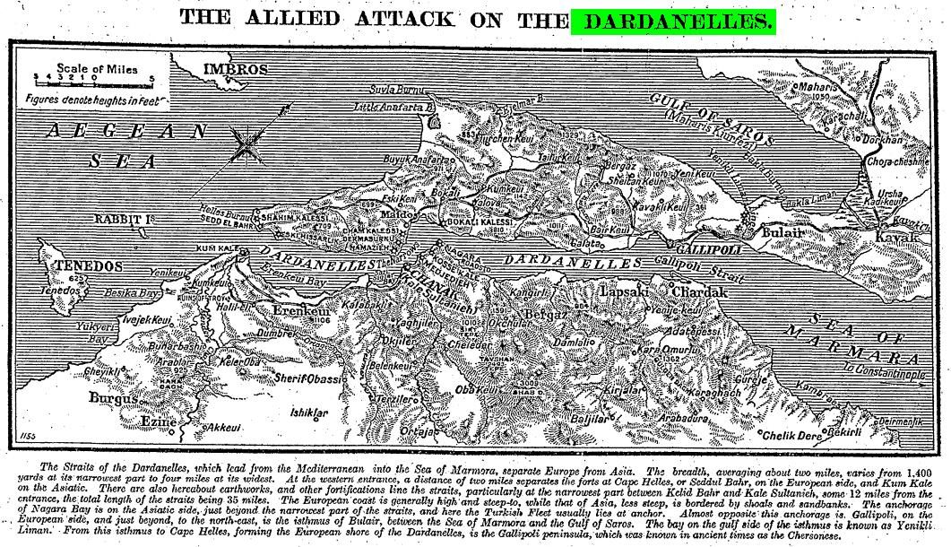
‘The allied Attack on the Dardanelles’, the Times, 22 February 1915.

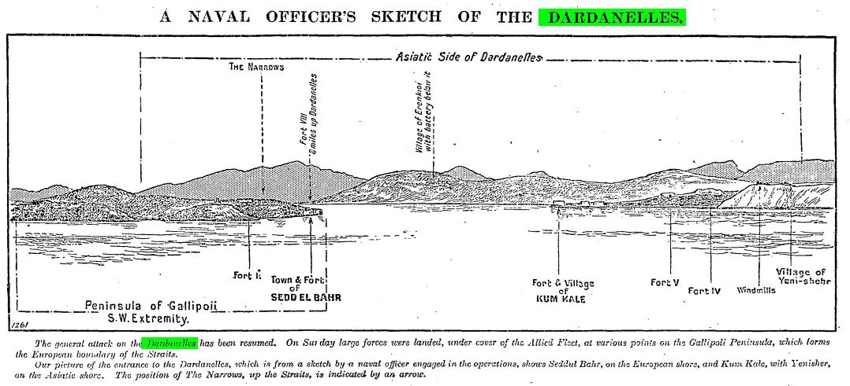
The Times, 27 April 1915.

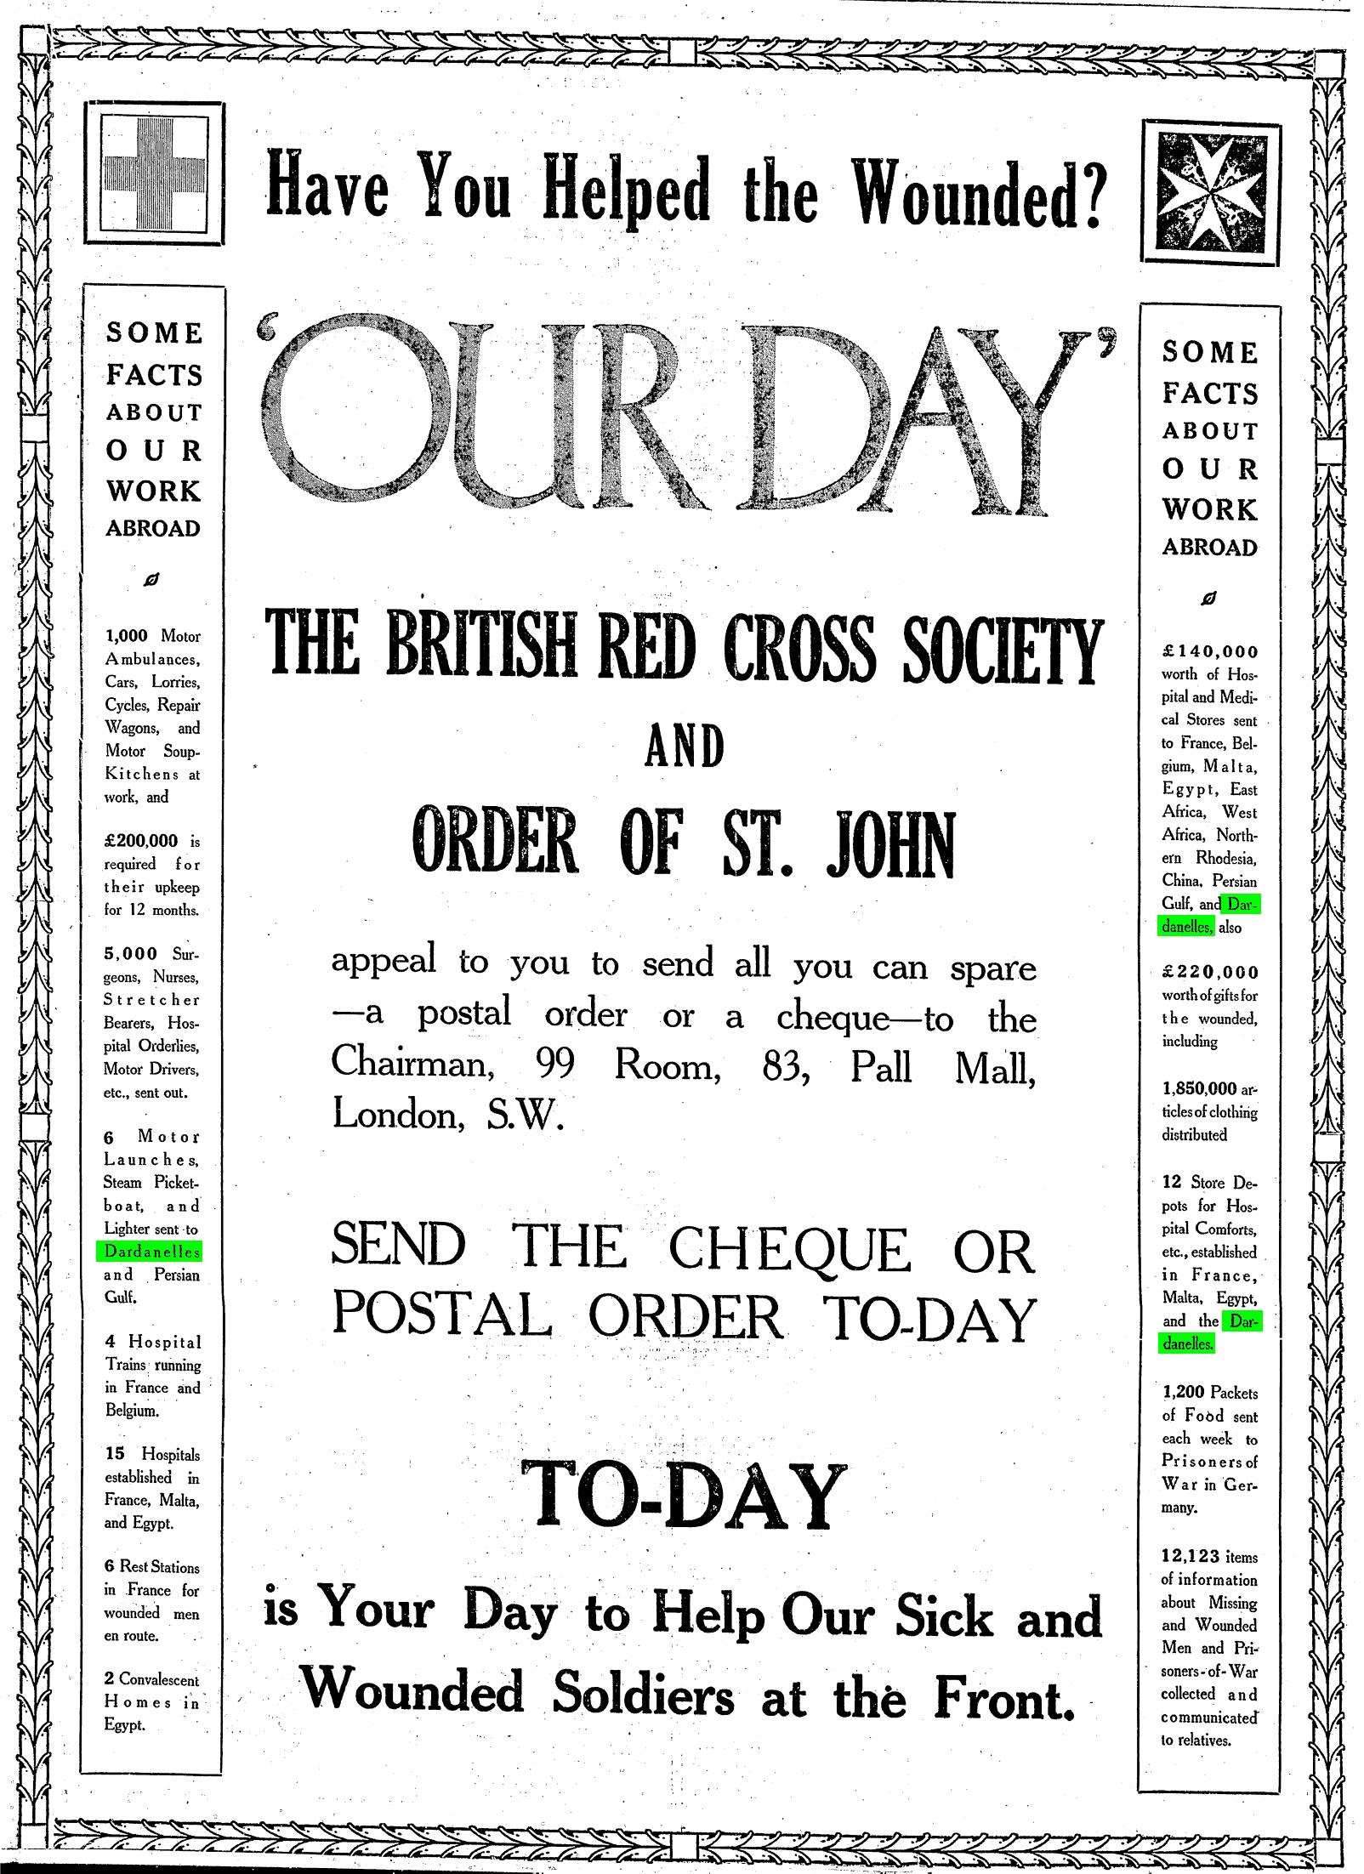
The Times, 21 October 1915.

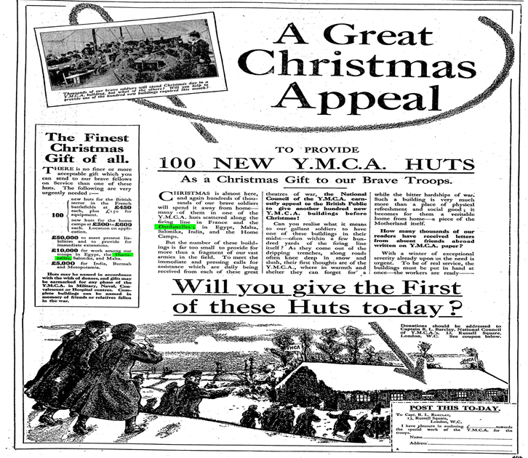
The Times, 8 December 1915

Bibliography
Badsey, S. 2009: The British Army in Battle and Its Image 1914-1918. London.
Bowman, W. D. 1931: The Story of the Times. London.
Churchill, W.: Statement to the Dardanelles Commissioners, PRO Cab 19/28
Fenton, L. 2012: Palmerston and the Times, Foreign Policy, the Press and Public Opinion in the Mid-Victorian Britain. London.
Ferguson, N. 1999: The Pity of War. London
Hansard Parliamentary Debates:
HC Deb 22 April 1915 vol. 71 cc400-1 accessed via http://hansard.millbanksystems.com/commons/1915/apr/22/press-censorship
Larkin, B. W. 2009: The Times and the Bulgarian Massacres, unpublished PhD thesis, Wesleyan University.
Miller, G. 1997: Straits British policy towards the Ottoman Empire and the origins of the Dardanelles campaign, Hull.
Oral, H.: Gallipoli 1915 2012: Through Turkish Eyes. Istanbul
Rasor, E. L. 2000: Winston S. Churchill 1874-1965, A Comprehensive historiography and Annotated Bibliography. USA.
The history of the Times, 1952: the 150th Anniversary and Beyond 1912-19148, part I, Chapters I-XII 1912-1920. London.
The Times Digital Archive:
The Declaration of War’, 5 August 1914.
‘Forcing the Dardanelles’, 01 March 1915.
‘The Dardanelles and After’, 5 March 1915.
‘The Narrows Key’, 26 April 1915.
‘The Times Fund’, 26 April 1915.
‘The Times Fund’, 26 April 1915.
‘One people and One Flag’, 30 April 1915.
‘Turks calling up every available man’, 01 May 1915.
‘The Empire at War’, 22 May 1915.
‘Mr. Churchill on his work’, 07 June 1915.
‘A call to the Empire’, 29 June 1915.
‘Heroism in Gallipoli’, 04 September 1915.
‘Australian Heroism’, 04 October 1915.
The Times, 13 October 1915.
‘1805 and 1915, A Trafalgar Day Comparison’, 21 October 1915.
‘Mr. Churchill resigns-Offer to serve in the Field’, 13 November 1915.
‘Mr. Churchill’s Statement’, 16 November 1915.
‘Through German Eyes’, 11 December 1915.
‘The Times and the war, to the editor of the Times’, 29 December 1915,
‘The Times Fund, Steady in Progress’, 04 January 1916
‘The Message of Gallipoli, to the editor of the Times’, 28 August 1916.
http://www.slate.com/articles/news_and_politics/american_military_history/2013/11/the_battle_of_gallipoli_winston_churchill_mustafa_kemal_and_the_battle_that.html (“It’s Like the Whole First World War in a Cup of Tea"; accessed on 13 February 2015)
http://www.nationalarchives.gov.uk/pathways/firstworldwar/battles/gallipoli.htm (‘Battles: the Gallipoli Campaign’; accessed on 13 February 2014.

‘The Message of Gallipoli’, to the editor of the Times, 28 August 1916.
Oral, H.: Gallipoli 1915: Through Turkish Eyes. Istanbul: Bahcesehir University Press, 2012.
Ferguson, N.: The Pity of War. London: Basic Books, 1999, p. 217
The Times, 13 October 1915.
Oral, H.: Gallipoli 1915: Through Turkish Eyes. Istanbul: Bahcesehir University Press, 2012 cited in http://www.slate.com/articles/news_and_politics/american_military_history/2013/11/the_battle_of_gallipoli_winston_churchill_mustafa_kemal_and_the_battle_that.html accessed on 12.11.2014
Bowman, W. D.: The Story of the Times. London: George Routledge & Sons Ltd., 1931, p. 1.
Larkin, B. W., ‘The Times and the Bulgarian Massacres’, unpublished PhD thesis, April 2009, faculty of Wesleyan University, p. 38
For further information Fenton, L.: Palmerston and the Times, Foreign Policy, the Press and Public Opinion in the Mid-Victorian Britain. London: I.B Tauris Co & Ltd., 2012, pp. 88-89.
Larkin 2009 p. 42.
The history of the Times, the 150th Anniversary and Beyond 1912-19148, part I, Chapters I-XII 1912-1920. London: The Office of the Times printing house square, 1952, p. 152.
The history of the Times, the 150th Anniversary and Beyond 1912-1914, part I, p. 155.
Ferguson 1999 p. 217
‘The Declaration of War’, the Times, 5 August 1914, pg.7; Issue 40595.
‘The Declaration of War’, the Times, 5 August 1914, pg.7; Issue 40595.
Churchill, W.: Statement to the Dardanelles Commissioners, PRO Cab 19/28 cited in Miller, G.: Straits British policy towards the Ottoman Empire and the origins of the Dardanelles campaign, Hull: The University of Hull Press, 1997, p. 344.
Cited in http://www.nationalarchives.gov.uk/pathways/firstworldwar/battles/gallipoli.htm accessed on 13 February 2014.
‘Forcing the Dardanelles’, the Times, 01 March 1915, pg. 9; Issue 40790.
‘The Narrows Key’, the Times, 26 April 1915, pg. 7; issue 40838.
‘The Times Fund’, the Times, 26 April 1915, pg.3; Issue 40838.
The Times Fund’, the Times, 26 April 1915, pg.3; Issue 40838.
‘The Times Fund, Steady in Progress’, the Times, 04 January 1916, pg.4; Issue 41054.
‘The Empire at War’, the Times, 22 May 1915, pg. 17; Issue: 40861.
‘One people and One Flag’, the Times, 30 April 1915, pg. 11; Issue: 40842.
‘A call to the Empire’, the Times, 29 June 1915, pg. 9; Issue: 40893.
Badsey, S.: The British Army in Battle and Its Image 1914-1918. London: British Library Cataloguing-in-Publication-Data, 2009, p. 18 cited in the History of the Times vol. IV. P. 218
‘The Dardanelles and After’, the Times, 5 March 1915, pg. 9; Issue: 40794.
Hansard Parliamentary Debates, HC Deb 22 April 1915 vol. 71 cc400-1 accessed via http://hansard.millbanksystems.com/commons/1915/apr/22/press-censorship on 13 February 2015.
‘Mr. Churchill on his work’, The Times, 07 June 1915, pg. 12, Issue; 40874.
The Times, 13 October 1915.
For a detailed account of the debate; Rasor, E. L.: Winston S. Churchill 1874-1965, A Comprehensive historiography and Annotated Bibliography. USA: Greenwood Press, 2000, p. 238.
‘Mr. Churchill resigns-Offer to serve in the Field’, the Times, 13 November 1915, p. 9; Issue: 41011.
‘Mr. Churchill’s Statement’, the Times, 16 November 1915, pg. 9; Issue: 41013.
‘Australian Heroism’, the Times, 04 October 1915, pg. 4, Issue; 40976.
‘Heroism in Gallipoli’, the Times, 04 September 1915, pg. 7, Issue; 40951.
‘1805 and 1915, A Trafalgar Day Comparison’, the Times, 21 October 1915, pg. 8; Issue; 40991.
‘Turks calling up every available man’, the Times, 01 May 1915, pg. 8, Issue; 40843.
‘Through German Eyes’, the Times, 11 December 1915, pg. 7, Issue; 41035.
‘The Times and the war, to the editor of the Times’, the Times, 29 December 1915, pg. 9, Issue; 41049.

